**CTO Candidate Task**

Strategic Planning and Team, Architecture, and

Tech Stack Evaluation

By

Yoganand Aiyadurai

Version 1.0

Dated: 14th August 2024

Contents

**1.** **Introduction** 4

2. **Team Evaluation and Restructuring** 4

Figure 1 Overview of the proposed structure 4

Security Engineer (1) *– Shared resource* 5

Game Mathematician (1) *– Shared resource* 5

Front-End Engineers (2/3) 5

Back-End Engineers (2/3) 5

Blockchain expert developer (1)  *– Shared resource* 5

Mobile Developers (2) 5

DevOps Engineer (2)  *– Shared resource* 6

QA Engineer (2) 6

Product Manager (1) 6

Data Analyst (1) 6

Game Designer (1) 6

IT Manager (1) 7

Support, Maintenance and Monitoring (3/2) *– Shared resource* 7

Design Team – Shared resource 7

Research and Development Team *– Shared resource* 7

Architecture Assessment and Improvements 7

Codebase and Architecture Review: 7

Figure 2 Architecture Assessments and Improvements 9

Security Assessment: 10

Infrastructure and Hosting Review: 10

DevOps and CI/CD Pipelines: 10

# **Introduction**

This document explains in details, elaboration of the ideas regarding the case study presentation of the findings and proposals.

# **Team Evaluation and Restructuring**

Given the context of managing two distinct products with different platforms and technologies, the initial team hires should focus on critical areas that ensure the ***security***, ***stability, scalability, maintainability, continuous improvement*** ***and portability*** of both products.

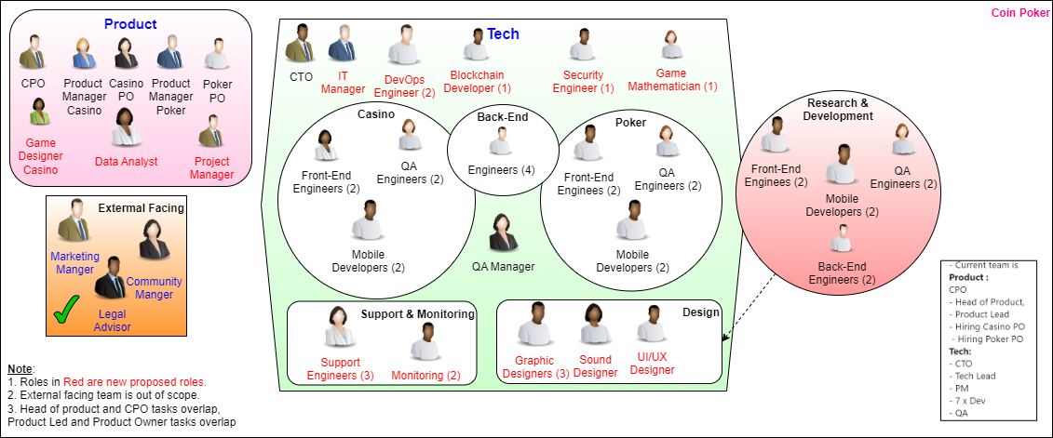

## Figure 1 Overview of the proposed structure

Below are the roles that are needed to make the game development team efficient and optimised.

## Security Engineer (1) *– Shared resource*

***Scope***: Focus on securing both products, especially the decentralized crypto wallet. They should conduct regular security audits, vulnerability assessments, and implement security best practices.

***Focus***: Data protection, encryption, secure transactions, and regulatory compliance.

## Game Mathematician (1) *– Shared resource*

***Scope:***  The heart of any casino game lies in its math engine. This engine determines how bets translate into outcomes. Game mathematicians create formulas for features like bonus rounds, free spins, and jackpots. They analyse probabilities, variance, and expected values to craft engaging gameplay.

***Focus***: Mathematics Model, Game Balance, Player Experience, and Game flow.

## Front-End Engineers (2/3)

***Scope***: Maintain and enhance the existing codebase for the poker & casino products (Android, Windows, Mac) and the crypto wallet (Android, iOS). They should be proficient in the relevant programming languages and frameworks used in these applications.

***Focus***: Bug fixing, new feature development, and performance optimization.

## Back-End Engineers (2/3)

***Scope***: Back-end developers collaborate closely with front-end teams to integrate game logic seamlessly into the user interface. This ensures a cohesive player experience.

***Focus***: Bug fixing, new feature development, Server-Side logic, database management, Game logic implementation, Scalability, Security and Fairness, and performance optimization.

## Blockchain expert developer (1) *– Shared resource*

**Scope:** Maintain and enhance the existing codebase for the decentralised crypto wallet, integrating new crypto currencies native to Android & Iphone,

Supporting the Full**-**stack and mobile developers.

***Focus***: crypto wallet, crypto currency Integrations, security, Bug fixing, new feature development, and performance optimization.

## Mobile Developers (2)

***Scope***: Specialize in Android and iOS development for the crypto wallet and poker/casino apps. They should focus on platform-specific features, UI/UX improvements, and OS updates.

***Focus***: Ensure smooth user experience across all devices and manage app store submissions.

## DevOps Engineer (2) *– Shared resource*

***Scope:*** Oversee the deployment pipelines, cloud infrastructure, and monitoring systems. They should ensure high availability, automated testing, and continues integration/continuous deployment (CI/CD).

***Focus:*** Infrastructure scalability, disaster recovery, Business continuity, and performance monitoring, high SLAs

## QA Engineer (2)

With test automation skills

***Scope:*** Create and execute test plans for both the crypto wallet and poker/casino products. They should work closely with developers to identify and fix bugs before release.

***Focus****:* Manual and automated testing, ensuring product quality, robust performance, Load & performance scalability, stability, volume & configuration testing, multi-platform compliance.

## Product Manager (1)

They ensure projects are completed on time, within budget, and meet quality standards.

***Scope***: Bridge the gap between technical and non-technical teams, manage product roadmaps, and gather user and product feedback. They should prioritize features and improvements based on business goals.

***Focus***: Strategic planning, user experience, and stakeholder communication.

## Data Analyst (1)

***Scope***: Analyse user behaviour, application performance, and financial metrics. They should provide insights to guide product decisions and marketing strategies.

***Focus***: Data-driven decision-making, reporting, and A/B testing.

## Game Designer (1)

***Scope***: Game designers are the creative masterminds behind the conceptualization and realization of a game. They blend technical skills, artistic vision, and narrative creativity to shape the game’s experience.

## IT Manager (1)

***Scope*:** The IT Manager would oversee the entire technical infrastructure, technical strategy development, ensuring both the poker/casino products and the decentralized crypto wallet operate smoothly across all platforms (Android, iOS, Windows, Mac).

***Focus*:** Ensure uptime, manage cloud services, oversee the deployment pipelines, and maintain hardware and software resources, manage day to day activities of the technical team, coordinating tasks, main point of contact between technical teams and other departments, aligning IT initiatives and business objectives.

## Support, Maintenance and Monitoring (3/2) *– Shared resource*

**Scope**: Customer Support, Monitoring and Maintenance.

***Focus***: Provides assistance to players, addressing issues and inquiries. Ensures the game servers and infrastructure are running smoothly and efficiently.

## Design Team – Shared resource

**UI/UX Designers**: Design intuitive and engaging user interfaces, focusing on user experience.

**Graphic Designers**: Create visual assets, including game graphics, animations, and promotional materials.

**Sound Designers**: Develop sound effects and music to enhance the gaming experience.

## Research and Development Team *– Shared resource*

**Scope**: Research emerging technologies, security, tackling threats, develop proof of concepts for both current and future product lines, maintain and enhance the game development framework, and take ownership of the system architecture. This includes conducting code and design reviews for framework changes, approving modifications, and introducing new, robust technologies, processes, and methodologies to improve game development efficiency. Additionally, work on integrating and exploring future technologies.

***Focus***: Research and development, Game development and architecture ownership, enabling the development to work with the robust and latest technologies, enhancing the efficiency of the game development teams.

______________________________________________________________________________________________________________________________________

# Architecture Assessment and Improvements

## Codebase and Architecture Review:

***Objective***: Assess the current state of the codebase for both products, focusing on:

* Security
* Scalability
* Maintainability
* Performance and reliability
* Compliance and adherence to best practices
* Portability
* Continuous improvement and enhancement
* Modifiability

***Recommendations***: If the code is outdated or overly complex, suggest refactoring, modularization, or even re-platforming. For example, transitioning a monolithic architecture to microservices if scalability is a concern. Implement ***DORA metrics*** for increasing the codebase quality and engineering practices.

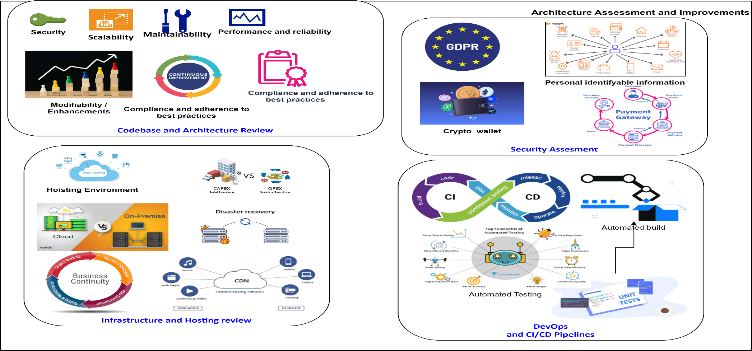

## Figure 2 Architecture Assessments and Improvements

## Security Assessment:

***Objective***: Conduct a thorough security review emphasising on security audit, penetration testing, PII (Personal identifiable information) and GDPR (General data protection regulation), particularly for the crypto wallet, which handles sensitive transactions and data.

***Recommendations***: Implement end-to-end encryption, multi-factor authentication, and regular security audits. For the poker & casino product, ensure secure payment gateways and anti-fraud measures are in place.

## Infrastructure and Hosting Review:

***Objective***: Evaluate the current hosting environment, including cloud services, databases, and server configurations. Pay for Use (OPEX vs CAPEX), If the systems are not in the cloud, then make strategic plan to move it the cloud as soon as possible.

***Recommendations***: If the current infrastructure is not scalable, consider moving to a cloud provider like AWS or Azure with auto-scaling capabilities, supporting disaster recovery, business continuity. Also, introduce load balancers, caching mechanisms, and CDNs to improve performance.

## DevOps and CI/CD Pipelines:

***Objective***: Review existing DevOps practices and deployment pipelines to cater for the current business needs.

***Recommendations***: If CI/CD pipelines are not in place, implement them to automate testing and deployments, reducing the risk of human error and increasing deployment frequency. This will require implementation of TDD, unit testing in development if these are not in place to support CI/CD.

__________________________________________________________________________________

# 4. What reporting would you look to provide the c suite team on a regular basis?

* **Weekly Status Reports:**

***Content***: Updates on product development, feature releases, and any critical issues or blockers. Include key metrics like DAUs, WAUs, MAUs, retention rates, and incident reports.

* **Monthly Performance Reports:**

***Content***: Detailed analysis of application performance, uptime, and user engagement metrics. Include comparisons with previous months and identify trends. OPEX reports on the cloud that can vary month by month and the infrastructure cost, subscriptions.

* **Quarterly Strategic Reports:**

***Content***: Long-term planning, including roadmaps for both products, budget forecasts, and hiring needs. Present risks, opportunities, and potential pivots.

* ***Security and Compliance Reports:***

***Frequency***: Quarterly or as needed.

***Content***: Findings from security audits, compliance checks, user experience management, and recommendations for mitigating risks.

__________________________________________________________________________________

**4. How would you identify team members who are not performing and what steps would you take to improve their performance?**

* **Performance Metrics:**

***Approach***: Define clear KPIs for each role, such as code quality, feature delivery timelines, and bug resolution rates for developers and DORA metrics for engineering practices. Use tools like JIRA, LinearB for tracking progress.

* **Regular Feedback Sessions:**

***Approach***: Conduct weekly one-on-one meetings to discuss performance, weekly achievements, any blockage, tracking the KPIS, and provide constructive feedback.

* **Training and Development:**

***Approach***: If a team member is underperforming, offer targeted training programs, mentorship, or pair programming opportunities. Identify the root cause of the problem, be open, and assure support and help.

* **Performance Improvement Plans (PIP):**

***Approach***: For persistent issues, implement a PIP with clear objectives, timelines, and consequences. Monitor progress closely and provide support and help with empathy.

__________________________________________________________________________________

**5. When requesting and managing budget for a technical team, what do you base this on?**

* **Baseline Costs**: Understand fixed costs (salaries, licenses, infrastructure, CAPEX, office space, equipments).
* **ROI Analysis**: Evaluate the impact of investments on business outcomes.
* **Basis for Budget Requests:**

***Considerations***: Align budget requests with the company's strategic goals, such as scaling infrastructure, enhancing security, or expanding the development team. Base requests on projected growth, user metrics, and product roadmap requirements. Always add 20% buffer.

__________________________________________________________________________________

**6. How do you manage budget efficiently (what support do you require from other executives to inform these decisions)?**

* **Efficient Budget Management:**

***Approach***:

* ***Prioritization***: Focus on high-impact areas like infrastructure stability, security, and critical hires.
* ***Monitoring***: Regularly review expenses against the budget and adjust allocations as needed.

***Support***: Collaborate with the CFO for financial insights, COO for aligning budget with operational goals, and CEO for understanding the business vison and collaborative strategic plans.

__________________________________________________________________________________

**7. How do you stay up to date with relevant technological advances within iGaming and crypto**

* **Industry Publications and Forums:**

***Approach***: Regularly read industry blogs, journals, and attend webinars. Engage in forums like GitHub, Stack Overflow, LinkedIn, or Reddit to stay informed about new technologies and trends in iGaming and crypto.

* **Conferences and Networking:**

***Approach***: Attend relevant industry conferences, such as GDC, ICE London, or blockchain-specific events. Network with peers to share knowledge and insights.

* **Continuous Learning:**

***Approach***: Enrol in online courses or certifications related to blockchain, crypto security, and gaming development. Encourage the team to do the same.

* **Internal Knowledge Sharing:**

***Approach***: Hold regular tech talks or brown-bag sessions where team members can share insights about new technologies they’ve explored. This fosters a culture of continuous learning.

* **Networking**: Engage with peers, join relevant forums, and participate in online communities.
* **Vendor Relationships**: Stay informed through interactions with technology vendors.
* **Internal Research**: Encourage team members to explore emerging trends and technologies.
* **Certifications on platform technologies**: windows, cloud, Linux.

**Stragery**

**Certainly! Let’s create a comprehensive plan for your company’s success, considering the short, mid, and long-term horizons. We’ll focus on three key areas: People, Process, and Technology Innovation.**

**1. Short-Term (0-6 months):**

**People:**

* **Hire Key Roles: As the first technical hire, prioritize recruiting essential team members:** 
  + **Software Engineers: To maintain and enhance existing products.**
  + **Product Managers: To drive product vision and strategy.**
  + **UI/UX Designers: To improve user experience.**
  + **Marketing Specialists: To boost exposure.**
* **Cross-Functional Collaboration: Foster communication between teams to align goals and streamline processes.**

**Process:**

* **Product Refinement:** 
  + **User Feedback Loop: Gather feedback from existing users to identify pain points and areas for improvement.**
  + **Iterative Development: Release frequent updates to address issues and add new features.**
* **Marketing and Promotion:** 
  + **Content Creation: Develop engaging content (blogs, videos, social media) to attract new users.**
  + **Partnerships: Collaborate with influencers or other relevant companies for cross-promotion.**

**Technology Innovation:**

* **Security Enhancements:** 
  + **Crypto Wallet: Strengthen security protocols to protect users’ assets.**
  + **Casino App: Ensure fair play and secure transactions.**
* **Performance Optimization:** 
  + **App Speed: Optimize code and database queries for faster load times.**
  + **Scalability: Prepare for increased user demand.**

**2. Mid-Term (6 months - 2 years):**

**People:**

* **Team Growth:** 
  + **Scale Up: Expand the engineering, design, and marketing teams.**
  + **Domain Experts: Hire experts in gambling, blockchain, and mobile app development.**
* **Leadership Development:** 
  + **Technical Leadership: Promote from within or hire experienced tech leads.**
  + **Product Visionaries: Identify individuals who can drive innovation.**

**Process:**

* **Agile Practices:** 
  + **Sprints: Implement agile methodologies for efficient development cycles.**
  + **Continuous Integration/Deployment: Automate testing and deployment.**
* **Data-Driven Decision-Making:** 
  + **Analytics: Leverage user data to inform product decisions.**
  + **A/B Testing: Experiment with different features and designs.**

**Technology Innovation:**

* **Blockchain Integration:** 
  + **Crypto Wallet: Explore decentralized finance (DeFi) integrations.**
  + **Smart Contracts: Enable secure and transparent transactions.**
* **AI and Personalization:** 
  + **Casino App: Use AI to personalize game recommendations.**
  + **Crypto Wallet: Predict user preferences.**

**3. Long-Term (2+ years):**

**People:**

* **Strategic Leadership:** 
  + **CTO/CIO: Hire a visionary leader to guide long-term technology decisions.**
  + **Industry Experts: Attract professionals with deep industry knowledge.**
* **Company Culture:** 
  + **Values: Define and promote a strong company culture.**
  + **Learning and Development: Invest in continuous learning for employees.**

**Process:**

* **Innovation Culture:** 
  + **Hackathons and Ideation Sessions: Encourage creativity and novel ideas.**
  + **Patent Strategy: Protect innovative technologies.**
* **Global Expansion:** 
  + **Localization: Adapt products for international markets.**
  + **Regulatory Compliance: Understand and comply with global regulations.**

**Technology Innovation:**

* **Emerging Technologies:** 
  + **Virtual Reality (VR): Enhance the casino experience.**
  + **AI/ML: Predictive analytics for personalized offers.**
  + **Quantum Computing: Investigate its potential impact.**

**Remember, adaptability and continuous learning are crucial. Regularly reassess your strategy and adjust based on market trends, user feedback, and technological advancements. Good luck on your exciting journey! 🚀🌟**